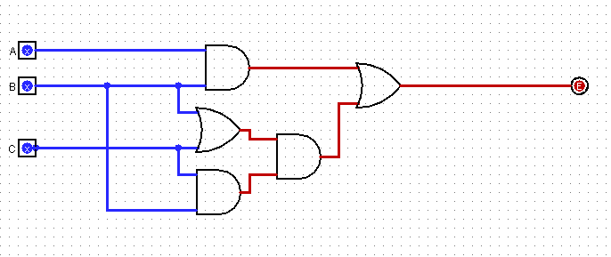

|  |  |  |  |  |  |  |  |
| --- | --- | --- | --- | --- | --- | --- | --- |
| A | B | C | AB | BC | B+C | AB+BC(B+C) | Q |
| 0 | 0 | 0 | 0 | 0 | 0 | 0 | 0 |
| 0 | 0 | 1 | 0 | 0 | 1 | 0 | 0 |
| 0 | 1 | 0 | 0 | 0 | 1 | 0 | 0 |
| 0 | 1 | 1 | 0 | 1 | 1 | 1 | 1 |
| 1 | 0 | 0 | 0 | 0 | 0 | 0 | 0 |
| 1 | 0 | 1 | 0 | 0 | 1 | 0 | 0 |
| 1 | 1 | 0 | 1 | 0 | 1 | 1 | 1 |
| 1 | 1 | 1 | 1 | 1 | 1 | 1 | 1 |

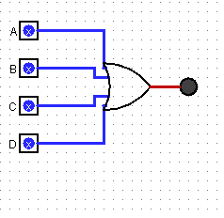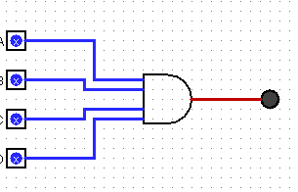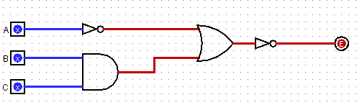

|  |  |  |  |  |  |  |  |
| --- | --- | --- | --- | --- | --- | --- | --- |
| A | B | C | D | D’ | AB | AB+C | (AB+C)D’ |
| 0 | 0 | 0 | 0 | 1 | 0 | 0 | 0 |
| 0 | 0 | 0 | 1 | 0 | 0 | 0 | 0 |
| 0 | 0 | 1 | 0 | 1 | 0 | 1 | 1 |
| 0 | 0 | 1 | 1 | 0 | 0 | 1 | 0 |
| 0 | 1 | 0 | 0 | 1 | 0 | 0 | 0 |
| 0 | 1 | 0 | 1 | 0 | 0 | 0 | 0 |
| 0 | 1 | 1 | 0 | 1 | 0 | 1 | 1 |
| 0 | 1 | 1 | 1 | 0 | 0 | 1 | 0 |
| 1 | 0 | 0 | 0 | 1 | 0 | 0 | 0 |
| 1 | 0 | 0 | 1 | 0 | 0 | 0 | 0 |
| 1 | 0 | 1 | 0 | 1 | 0 | 1 | 1 |
| 1 | 0 | 1 | 1 | 0 | 0 | 1 | 0 |
| 1 | 1 | 0 | 0 | 1 | 1 | 1 | 1 |
| 1 | 1 | 0 | 1 | 0 | 1 | 1 | 0 |
| 1 | 1 | 1 | 0 | 1 | 1 | 1 | 1 |
| 1 | 1 | 1 | 1 | 0 | 1 | 1 | 0 |